Advanced Living Systems Lab
Overview

Time: 2 hours
Group Size: Up to 45 participants (10-15 students per group)
Grade Levels: 6th – 8th grade
Location: At Sea

PROGRAM DESCRIPTION

The Advanced Living Systems Lab program is an advanced version of our popular Living Systems Lab. During this 2-hour lab, students will investigate relationships between biotic and abiotic components in the marine ecosystem. Students will perform testing procedures on water samples to assess environmental factors that impact marine organisms. They will also investigate anatomical similarities among marine organisms to determine patterns in classification systems. Students will dissect a fish and explore their external and internal anatomy in order to identify the complex systems within fish and to discuss its role in its habitat. Lastly students will investigate the moon jelly life cycle and the ways that moon jellies can impact their ecosystems.

INTRODUCTION

If the group is even a few minutes late it must be shortened. Stations should start no more than 15 minutes after the program start time, so shorten introduction as needed. If they are more than 15 minutes late in arriving, you will need to do this in 5 minutes and shorten stations as required to finish on time. You may even need to divide groups right away and do your own brief introduction with your group.
While one instructor is giving the intro, another instructor needs to group up the chaperones and give a chaperone talk.
Introduction:
Welcome to the Ocean Institute. Introduce self and instructors.
“In this program we are going to explore different systems in the ocean and how they connect. What is a system? (guide them to talk about all parts working together for a function) What does an ecosystem need to function? (Answers will vary). Ecosystems are composed of abiotic and biotic factors. (If time, discuss what these two terms mean. Otherwise do it at stations). Life cycles and food chains are also systems. Would they work without all of their parts?”
Briefly introduce the four stations and let students know they will be broken up into the appropriate number of groups.
Go over expectations for behavior and safety. No running. Stay with your group. No tapping on the tanks. No flash photography.

Chaperone Talk:
Welcome to the Ocean Institute! Thank you for coming and giving your time so your students may have this experience.
Give a brief description of the program, timing, and rotations (ex. During this two hour living systems lab, students will move through four 25- minute stations with their group, each focusing on a different aspect of systems in the ocean).
Role of the chaperones:
- Our labs are inquiry-based learning stations meant to challenge and inspire the students, so we ask that you take a step back and allow them to fully engage in all of the stations.
- Please stay with the group you begin with and help the students focus on their work. Please assist with any behavior management issues.
- Your instructor may ask you to supervise the students in the event they need to step away or prepare lab materials, so please be prepared to step in.
- Please help the instructor by taking any students to the bathroom.
- Pictures of students should be candid so as not to distract from activities.
Breaking into Groups:
The instructor that talked to the teacher should give the student count and any information on groups to the instructor doing the introduction. If they have grouped in advance, the teacher will want to use them. If they have not, it is best if the teacher will just let you count off students, so no time is wasted. Do not do a 1- 2- 3 count, just quickly count off the number of students you need without looking like you are picking individual students out. Try to take a mix of both girls and boys. Make sure to count the number of students you have when you get to the first station, make sure you have the right number.

FOUR STATIONS

1. Fish Dissection:
Students will observe form and function of the external anatomy and with this information make a hypothesis on the habitat of a mackerel. Using this information, they will generate a hypothesis about mackerel diet. They will then dissect the mackerel to examine the digestive system and test their hypothesis. The dissection will continue with the eye to observe the lens and its adaptation to the ocean environment. Continue with the respiratory system, circulatory system, and any other organs as time permits. With a higher grade level (8th grade and up), the dissection can continue with a discussion on the overall health of the fish, or any indication of bioaccumulation or pollution on this type of fish.

2. Water Chemistry
Students test and record the non-living (abiotic) factors including temperature, salinity, and pH of various water samples, while an instructor demonstrates testing for dissolved oxygen. Students discuss how unfavorable water conditions can affect animals with distinct ranges and how the animals may affect the water quality of their tanks, as well.

3. Invertebrate Biodiversity and Classification
Students will learn the characteristics of marine invertebrate phyla that are represented in our tank farm. In this activity, students will use a field guide to locate four assigned invertebrate animals. Using their observation skills, they will list some of the general characteristics found in these animals. The students will then be supplied with a general classification sheet listing common characteristics for each represented invertebrate phylum. Using this information, they will identify what phylum their assigned animals are in and explain their reasoning.

4. Jelly Biology and Ocean Imbalance
Jellies often occur in large swarms that can cause damage to an ecosystem. Some scientists feel these swarms are increasing in number and size and are a sign of environmental degradation. At this station we will look at the jellies and make a hypothesis on what makes it possible for jellies to appear from ‘out of nowhere’ and to produce great population blooms. We will start by gathering information about the jellies in order to make an informed hypothesis.

SCHEDULE/LOGISTICS

Perfect Timing Example: (25) Minutes per stations
9:30 – 9:45 Bring in, Sit them Down, Introduction, Divide into Groups
9:45 – 10:10 Station 1
10:10 – 10:35 Station 2
10:35 – 11:00 Station 3
11:00 – 11:25 Station 4
11:25-11:30 Line up and out the door

- Program Set Up:
- If it is the first program of your day, arrive 30 minutes before program start time. Read challenge sheets for equipment and preparation needed for each station. Make sure to get the fish out first, as they take time to thaw. If there are two Adv. Living Systems programs at the same time, one will be run in Sahm. Make sure to use the equipment in the Sahm cabinets and not to mix them with the At Sea equipment.
- Bring Them In:
- Decide who will do the introduction during set up time; it is important to start the program on time.
- Staff should go to the front the Ocean Institute when set up is done (at least 10 minutes before program start time). If the science coordinator is not available for check-in, one instructor can talk to the teacher to get numbers, make sure they have checked in, discuss groups, etc. while the other instructors get the students ready to go in and bring up the rear to close the side gate.
- If there is time, you can have the students use the restroom before bringing them into the lab for an introduction. If the school is more than 15 minutes late, please talk to the teacher to see if they can wait to go to the bathroom until lab begins.
- If it is not raining have the students put any gear, backpacks, etc. in the buckets outside of the At Sea building before they come into the room. Make sure students sit on the floor, not blocking the doors to the tank farm or husbandry office.
- Give Introduction and Break into Groups

- Station rotation (25 minutes each): 1) Fish Dissection 2) Water Chemistry 3) Invertebrate Biodiversity and Classification 4) Jelly Biology and Ocean Imbalance

- Conclusion/Ending Program:
- Finish on time, line them up at the door. Make sure they know their program is over and ask the teacher what is next for them. Direct them to where they need to go. Make sure they understand they are to leave the campus. No eating lunch in the firepit area. Groups can go out into the Native Plant Garden to eat lunch and will not be allowed back on campus until lunch is over. Instructors take a 30-minute break while students are off campus eating their lunch.

ROOM DIAGRAMS

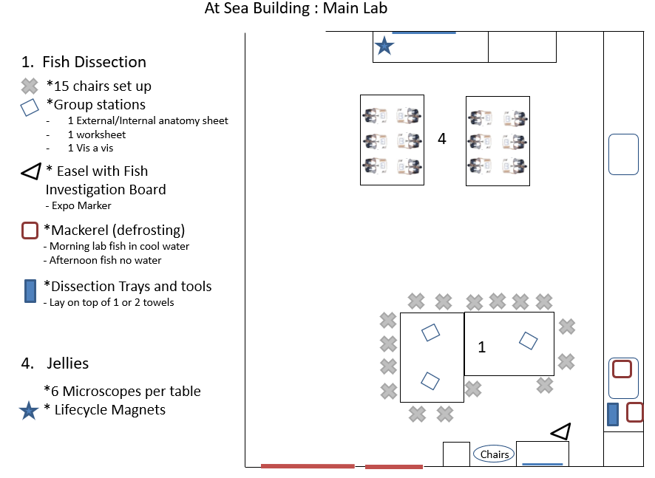

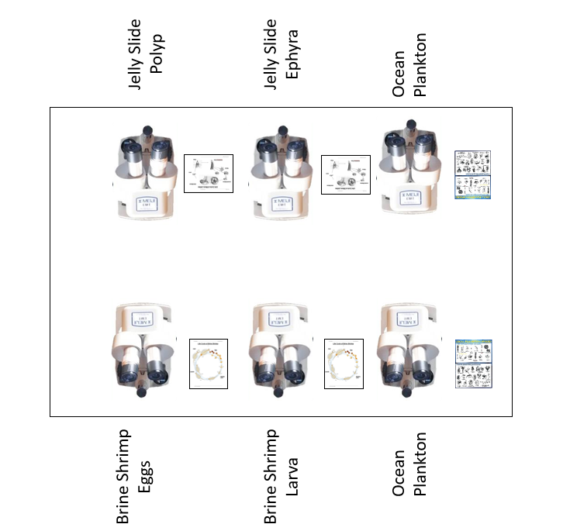

Microscope Set Up (2 Identical Tables)

4

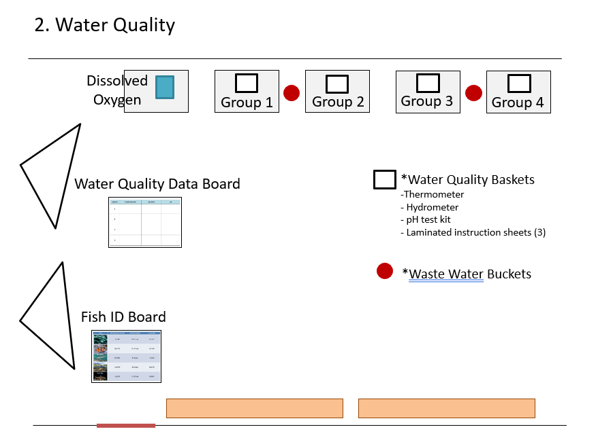

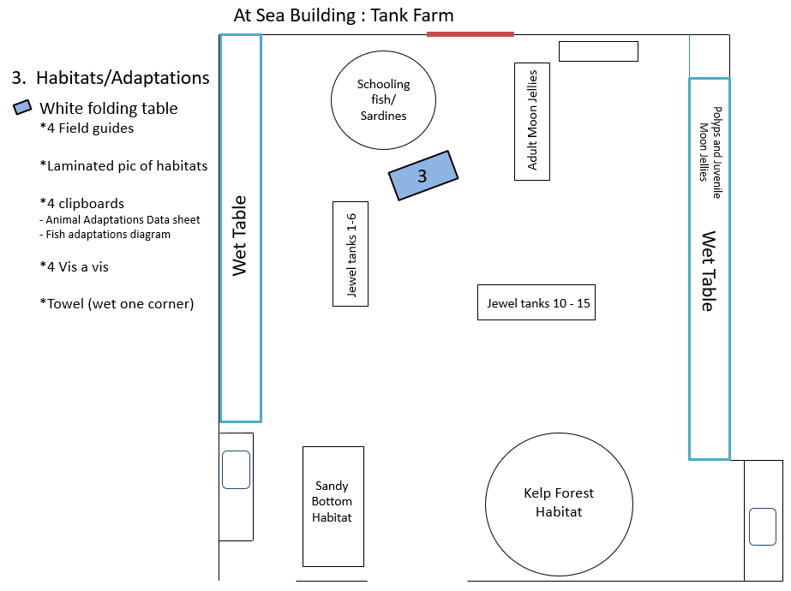

Stations (in order):
- Fish Dissection
  - Set up 10-15 chairs around tables. Pull out all dissection materials and set up next to the sink in At Sea. Pull dissection sheets out of the black cabinet and place on the tables for students to use.
- Water Chemistry
  - Materials are located in the Living Systems cabinet in At Sea. Transport the student boxes, DO box and instruction sheet, water testing instruction sheets, waste buckets, and four water sample containers. The student data board, fish board, and easels are located in the red bin and should be set up where students can easily access them.
- Invertebrate Biodiversity and Classification
  - Set up one folding table in front of the schooling fish tank. Get four clipboards from the red bin. Place designated sheets on clipboard along with the field guides and vis-à-vis wet-erase markers on folding table.
- Jelly Biology and Ocean Imbalance
  - Place four clipboards with designated jelly sheets and vis-à-vis markers on the bench in front of the Jelly Life Cycles poster. In the adjacent room, place 12 microscopes on two lab tables (six per table). Each table will have two jelly slides, two ocean plankton samples, and two brine shrimp eggs/adults samples. Pull power outlets down from the ceiling.

STANDARDS

NGSS EXCERPTS DIRECTLY RELATED TO:
For more in-depth descriptions of these standards, please view at https://www.nextgenscience.org/

MS-LS1-3 Use argument by evidence for how the body is a system of interacting subsystems composed of groups of cells.
- [Clarification Statement: Emphasis is on the conceptual understanding that cells form tissues and tissues form organs specialized for particular body functions. Examples could include the interaction of subsystems within a system and the normal functioning of those systems.]
MS-LS1-4 Use argument based on empirical evidence and scientific reasoning to support an explanation for how characteristic animal behaviors and specialized plant structures affect the probability of successful reproduction of animals and plants respectively.
- [Clarification Statement: Examples of behaviors that affect the probability of animal reproduction could include nest building to protect young from cold, herding of animals to protect young from predators, and vocalization of animals and colorful plumage to attract mates for breeding. Examples of animal behaviors that affect the probability of plant reproduction could include transferring pollen or seeds and creating conditions for seed germination and growth. Examples of plant structures could include bright flowers attracting butterflies that transfer pollen, flower nectar and odors that attract insects that transfer pollen.]
MS-LS1-5 Construct a scientific explanation based on evidence for how environmental and genetic factors influence the growth of organisms.
- [Clarification Statement: Examples of local environmental conditions could include availability of food, light, space, and water. Examples of genetic factors could include large breed cattle and species of grass affecting growth of organisms. Examples of evidence could include drought decreasing plant growth, fertilizer increasing plant growth, different varieties of plant seeds growing at different rates in different conditions, and fish growing larger in large ponds than they do in small ponds.]
MS-LS2-1 Analyze and interpret data to provide evidence for the effects of resource availability on organisms and populations of organisms in an ecosystem.
- [Clarification Statement: Emphasis is on cause and effect relationships between resources and growth of individual organisms and the numbers of organisms in ecosystems during periods of abundant and scarce resources.]
MS-LS2-2 Construct an explanation that predicts patterns of interactions among organisms across multiple ecosystems.
- [Clarification Statement: Emphasis is on predicting consistent patterns of interactions in different ecosystems in terms of the relationships among and between organisms and abiotic components of ecosystems. Examples of types of interactions could include competitive, predatory, and mutually beneficial.]
MS-LS2-4 Construct an argument supported by empirical evidence that changes to physical or biological components of an ecosystem affect populations.
- [Clarification Statement: Emphasis is on recognizing patterns in data and making warranted inferences about changes in populations, and on evaluating empirical evidence supporting arguments about changes to ecosystems.]
MS-LS4-2 Apply scientific ideas to construct an explanation for the anatomical similarities and differences among organisms and between modern and fossil organisms to infer evolutionary relationships.
- [Clarification Statement: Emphasis is on explanations of the evolutionary relationships among organisms in terms of similarity or differences of the gross appearance of anatomical structures.]

